Torrent salamander

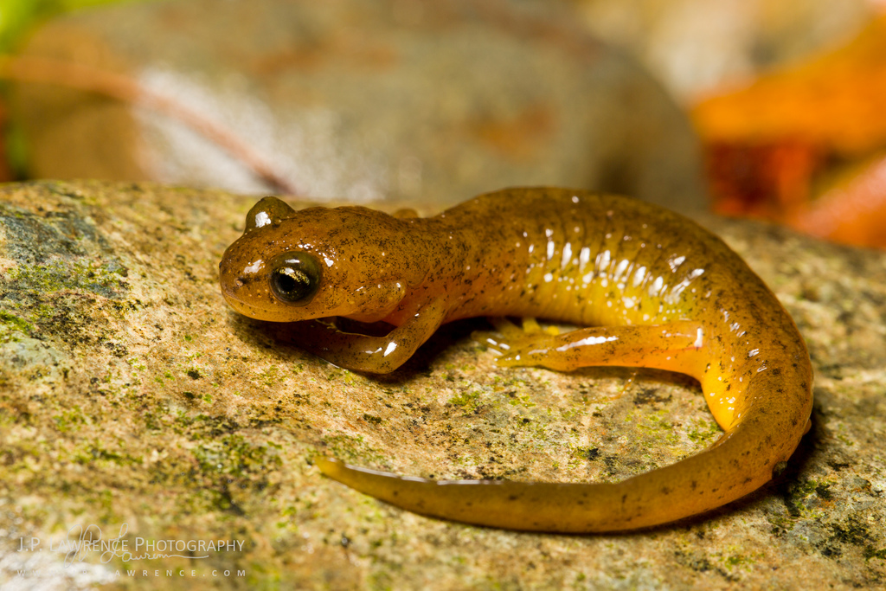

The **torrent salamanders** or **Cascade salamanders** are a [family](https://en.wikipedia.org/wiki/Family_(biology)) (Rhyacotritonidae) with only [one genus](https://en.wikipedia.org/wiki/Monotypic) (*Rhyacotriton*) of [salamanders](https://en.wikipedia.org/wiki/Salamander). Originally the [genus](https://en.wikipedia.org/wiki/Genus) *Rhyacotriton* was placed in the family [Ambystomatidae](https://en.wikipedia.org/wiki/Ambystomatidae" \o "Ambystomatidae), later in the family [Dicamptodontidae](https://en.wikipedia.org/wiki/Dicamptodontidae" \o "Dicamptodontidae), and finally in 1992 it was placed into a family of its own. At the same time the only species *Rhyacotriton olympicus* was split into four species due to genetic analysis. The torrent salamanders are limited to the western USA, namely the states [California](https://en.wikipedia.org/wiki/California), [Oregon](https://en.wikipedia.org/wiki/Oregon), and [Washington](https://en.wikipedia.org/wiki/Washington_(state)).

The genus *Rhyacotriton* is divided into four species:

* [Cascade torrent salamander](https://en.wikipedia.org/wiki/Cascade_torrent_salamander) (*R. cascadae*)
* [Columbia torrent salamander](https://en.wikipedia.org/wiki/Columbia_torrent_salamander) (*R. kezeri*)
* [Olympic torrent salamander](https://en.wikipedia.org/wiki/Olympic_torrent_salamander) (*R. olympicus*)
* [Southern torrent salamander](https://en.wikipedia.org/wiki/Southern_torrent_salamander) (*R. variegatus*)